Tao Ye, FRSC

Professor, Deputy Dean, School of Chemical Biology & Biotechnology, Peking University Shenzhen Graduate School, Xili, Nanshan District, Shenzhen, 518055, China; Email: [yet@pkusz.edu.cn](mailto:yet@pkusz.edu.cn); or tao_ye35@hotmail.com

Web: http://web.pkusz.edu.cn/ye/

EDUCATION

1989-1993 Ph.D., Queen’s University, Belfast, with Professor Tony McKervey

1983-1986 M.Sc., East China University of Science & Technology

1979-1983 B.Sc., East China University of Science & Technology

PROFESSIONAL EXPERIENCE

2015- Professor & Senior PI, Peking University Shenzhen Graduate School

2002-2015 Deputy Director of Institute of Materia Medica, Associate Professor, Hong Kong Polytechnic University

1998-2002 Research Assistant Professor, The Hong Kong of University

1994-1998 ROPA Fellow, Nottingham University, with Professor Gerry Pattenden

1993-1994 Postdoctoral Fellow, Queen’s University, Belfast, with Professor Tony McKervey

**HONORS AND AWARDS**

2019 Guest Professor, Hokkaido University (Japan)

2015 Fellow of the Royal Society of Chemistry, 2015

2014 Xiaoyu Hu Memorial Award

2012 WuXi PharmaTech Life Science and Chemistry Award

2012 Asian Core Program Lectureship Award 2012 (To deliver lectures in Japan)

2012 Asian Core Program Lectureship Award 2012 (To deliver lectures in Beijing)

1994-1998: ROPA Fellowship (Engineering and Physical Sciences Research Council, U.K.)

1991 Prize Winner of “The Pfizer Organic Chemistry Poster Symposium”

**PROFESSIONAL SERVICE**

* Member of Advisory Board of “Organic Chemistry Frontiers”
* Associate Editor (2013-2017) “Frontiers in Chemical Biology”
* Member of Senior Editorial Board of "American Journal of Cancer Research",
* Member of Editorial Board of "Journal of Pharmaceutics".
* Member of Editorial Board of "Natural Products Chemistry & Research"
* Member of Editorial Board of "Chemical Biology Letters"

RESEARCH INTEREST

Our research interests span the disciplines of natural product synthesis, chemical biology, synthetic biology and drug discovery, which include the discovery and development of new agents of medicinal value through major advances in chemical synthesis and biosynthesis. Currently, we are working in two main areas:

1. **Synthesis and Biological Evaluation of Natural Products and Their Analogues.** Natural products have provided considerable value to the pharmaceutical industry over the past half century. In particular, the therapeutic area of oncology has benefited from numerous drug classes derived from natural product sources. Synthesis of natural products and their analogues has been a key tool in drug discovery and development. The synthesis allows verification of primary structure proposed on the basis of studies of natural product, and presents opportunities to modify the structure, with the ultimate aim of improving activity or physicochemical/biological properties of the lead molecule. Synthesis is also crucial in the establishment of structure-activity relationships since the ability to make analogues of the lead compound chemically and/or biochemically is a prerequisite of drug discovery. We have been particularly devoting to the exploration of natural-products-based drug discovery. The larger part of our research program is dedicated to the training and research in chemical synthesis, biosynthesis and biological evaluation of natural products with known biological activities. Structures of some completed molecules are shown below:







1. **Design and Syntheses of Novel Small Molecule Bioprobes and Drugs.**

Protein–protein interactions play a key role in most biological processes, and offer attractive opportunities for therapeutic intervention. The targeted manipulation of protein-protein interactions with the use of small molecules is rapidly gaining importance in the development of biological tools for dissecting living processes on a molecular level and for the discovery of conceptually novel drugs. Our research centers on rationally designed molecular probes / drug candidates, and their application to biological problems, especially in cancer biology and neurodegenerative disorders.

1. **Development of** **Structural- and/or Functional- diversity Oriented Methodologies**

Despite rapid advances in synthetic organic chemistry, the construction of intriguing small molecules via traditional methods suffers from insufficient efficacy. By combining the power of transition metal catalysis, enzymatic tools and photocatalysis, our laboratory develops practical solutions for conventionally challenging organic transformations, aiming to deliver diverse novel structures and functions to chemical science community.

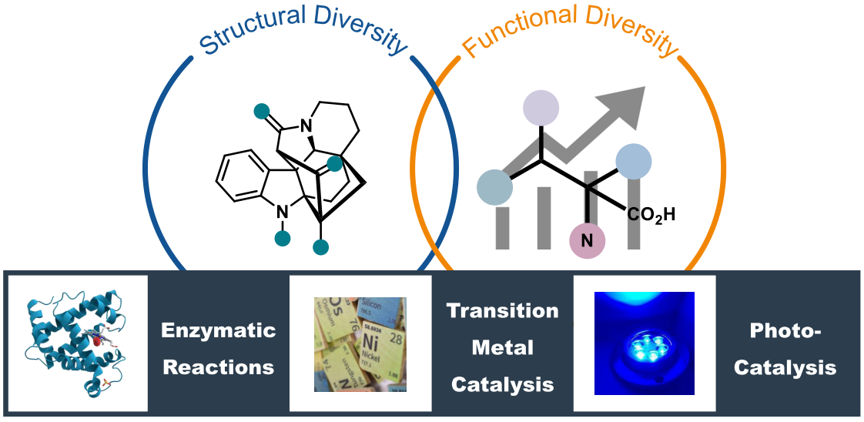

SELECTED PUBLICATION (2010-)

1. “Asymmetric Total Syntheses of Kopsane Alkaloids via a PtCl2-Catalyzed Intramolecular [3+2] Cycloaddition” *Angew. Chem. Int. Ed.* **2020**, *59*, 12832-6;
2. “Total synthesis of antiallergic bicyclic peptide seongsanamide A” *Org. Chem.Front.* **2020**, 7, 1658-62
3. “Total Synthesis of Dysoxylactam A” *Org. Lett.* **2020**, *22*, 1776-9;
4. “Reductase of Mutanobactin Synthetase Triggers Sequential C−C Macrocyclization, C−S Bond Formation, and C−C Bond Cleavage” *Org. Lett.* **2020**, *22*, 960-4;
5. “Total Synthesis of Hoiamide A Using an Evans-Tishchenko Reaction As a Key Step” *Org. Lett.* **2019**, *21*, 5471-4;
6. “Total Synthesis of Psymberin (Irciniastatin A)” *Org. Lett.* **2019**, *21*, 3670-3;
7. “Discovery of Amantamide, a Selective CXCR7 Agonist from Marine Cyanobacteria” *Org. Lett.* **2019**, *21*, 1622–6;
8. “Total Synthesis of Asperphenins A and B” *Org. Lett.* **2018**, *20*, 6170-3;
9. “Total Synthesis of Anti-tuberculosis Natural Products Ilamycins E1 and F” *Org. Lett.* **2018**, *20*, 6166-9;
10. “Discovery and Characterization of Brintonamides A‒E, Novel Dual Protease and GPCR Modulators from a Marine Cyanobacterium Targeting Breast Cancer Metastasis” *J. Med. Chem.* **2018**, *61*, 6364−78;
11. “Studies toward the Synthesis of Iriomoteolide-2a: Construction of the C(6)−C(28) Fragment” *Org. Lett.* **2018**, *20*, 2213-5;
12. “Genome Mining and Assembly-Line Biosynthesis of the UCS1025A Pyrrolizidinone Family of Fungal Alkaloids” *J. Am. Chem, Soc.* **2018**, *140*, 2067-71;
13. “Total synthesis of amphidinins E, F and epi-amphidinin F” *Org. Chem. Front.* **2018**, *5*, 629-32;
14. “Regio- and Stereospecific Construction of 3a-(1H‑Indol-3-yl)pyrrolidinoindolines and Application to the Formal Syntheses of Gliocladins B and C” *Org. Lett.* **2017**, *19*, 5134−7;
15. “Total Synthesis and Stereochemical Assignment of Actinoranone” *Chem. Eur. J.* **2017**, *23*, 3572–6;
16. "Concise Total Synthesis of Nannocystin A", *Angew. Chem. Int. Ed.* **2016**, *55*, 13263-6. This paper has been featured by SYNFACTS Highlights in *Current Synthetic Organic Chemistry* 2016, 12, 1228
17. “Total Synthesis and Stereochemical Assignment of Callyspongiolide” *J. Am. Chem. Soc.* **2016**, *138*, 6948-51;
18. “Discovery, Total Synthesis and Key Structural Elements for the Immunosuppressive Activity of Cocosolide, a Symmetrical Glycosylated Macrolide Dimer from Marine Cyanobacteria” *Chem. Eur. J.* **2016**, 22, 8158-66;
19. "Discovery of Mandelalide E and Determinants of Cytotoxicity for the Mandelalide Series" *Org. Lett.* **2016**, *18*, 1374-7;
20. “The total synthesis and stereochemical assignment of scytonemin A”, *Chem. Commun.*, **2016**, *52*, 1002-5;
21. “Total synthesis of largamide B” *Chem. Commun.* **2015**, *51*, 2510-13. (This paper has been featured on the intra-front cover ofissue 13, volume 51 (2015) of Chemical Communications)
22. “Total Synthesis and Stereochemical Reassignment of Mandelalide A” *Angew. Chem. Int. Ed.* **2014**, *53*, 6533-37. (hot paper)
23. "LSD1 Regulates Pluripotency of Embryonic Stem/Carcinoma Cells through HDAC1-mediated Deacetylation of Histone H4 at Lysine 16" *Mol. Cell. Biology* **2014**, 34, 158-79
24. "Total Synthesis and Biological Evaluation of Grassypeptolide A" *Chem. Euro. J.,* **2013**, *19*, 6774-84.;
25. "Total Synthesis of Padanamides A and B" *Chem. Commun.* **2013**, *49*, 2977-9. (This paper has been featured on the intra-front cover of issue 29, volume 49 (2013) of Chemical Communications)
26. "A Novel CyclinE/CyclinA-CDK2 Inhibitor Targets p27Kip1 Degradation, Cell Cycle Progression and Cell Survival: Implications in Cancer Therapy" *Cancer Letters,* **2013**, *333*, 103-12;
27. "A histone deacetylase inhibitor largazole decreases liver fibrosis and angiogenesis by inhibiting TGF-β and VEGF signalling"*Liver International*, **2013**, 504-15.;
28. "Pluripotent Stem Cell Protein Sox2 Confers Sensitivity towards LSD1 Inhibition in Cancer Cell", *Cell Reports*, **2013**, *5*, 445-57;
29. "Total Synthesis and Stereochemical Revision of Lagunamide A" *Chem. Commun.* **2012**, *48*: 8697-9;
30. "Total Synthesis and Absolute Configuration of Nocardioazine B" *Chem. Commun*. **2012**, *48*: 4344-6.;
31. "Novel Histone Demethylase LSD1 Inhibitors Selectively Target Cancer Cells with Pluripotent Stem Cell Properties" *Cancer Res.* **2011**, *71:* 7238-49. This paper was highlighted by NATURE (China).
32. “Total Synthesis of Hoiamide C” *Org. Lett.* **2011**, *13*, 2506-9.
33. “Inhibition of PDGF, TGF-β and Abl Signaling and Reduction of Liver Fibrosis by the Small Molecule Bcr-Abl Tyrosine Kinase Antagonist Nilotinib”, *J. Hepatology*, **2011**, *55*, 612-25.
34. "Total Synthesis of Grassypeptolide" *Chem. Commun.* **2010**, 46; 7486-8. This paper was featured on the intra-front cover of issue 40, volume 46, (2010) of Chemical Communications and highlighted by NATURE (China).
35. “Synthesis of the Macrocyclic Core of Iriomoteolide-1a”, *Chem. Commun.* **2010**, *46*, 4773-5;
36. “Total Synthesis and Stereochemical Reassignment of Bisebromoamide” *Org. Lett.* **2010**, *12*, 3018-21;
37. “Synthesis of the C9−C23 (C9’-C23’) Fragment of the Dimeric Natural Product Rhizopodin” *Org. Lett.* **2010**, *12*, 2036-9;
38. “Total Synthesis of Sintokamide C” *Org. Lett.* **2010**, *12*, 1100-3;
39. “Towards the Stereochemical Assignment of Natural Lydiamycin A” *Chem. Commun.* **2010**, *46*, 574-6;
40. “Total Synthesis of Largamide H” *Chem. Commun.* **2010**, *46*, 153-5.

**Book:** “Modern Catalytic Methods for Organic Synthesis with Diazo Compounds: From Cyclopropanes to Ylides” (652 pages), Doyle, M. P.; McKervey, M. A.; Ye, Tao, John Wiley & Sons, Inc., New York. **1998**